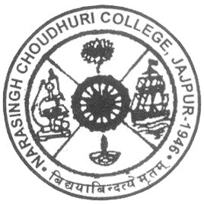

N.C.( Narasingh Choudhury) Autonomous College

(Established- 1946)

ACADEMIC CALENDER 2024

Department of Self-financing Studies

|  |  |
| --- | --- |
| ACTIVITY | TENTATIVE DATE |
| Autumn Academic Sessions | 1st week of July to 4th week of December |
| Academic Induction/Sharing of Academic Vision | 1st week of July |
| Internal Exam/Mid-term Exam | 3rd week of October |
| Semester Exam/End-term Exam | 1st week of December to 3rd week of December |
| Starting of New Semester /Spring Academic session | 1st week of January |
| Internal Exam/ Mid-term Exam | Last week of February |
| Semester Exam/End-term | 2nd week of April to 4th week of April |
| Summer Vacation | 5th May to 16th June |