**DEPARMENT PROFILE**

**NAME OF THE DEPARTMENT: DEPARTMENT OF ECONOMICS, N.C. AUTONOMOUS COLLEGE, JAJPUR**

**OUR MISSION:**

* To promote tolerance and fellow-feeling among students for mutual accommodation of interests.
* To promote a set of Values to strengthen human bonds.
* To build students as effective instruments of social change.
* To promote a scientific temper and inquisitive spirit for a brighter tomorrow.
* To create a favourable environment for women's empowerment on account of the numerical strength of women learners.

**OUR VISION:**

The institution envisions a bright future for learners who are mostly from rural backgrounds and aims to empower them with knowledge and motivation for research.

**HISTORY OF THE DEPARTMENT:**

N.C. Autonomous College, Jajpur came into being in 1946 and Economics was introduced as an Honours subject. Later the Department of Economics started with the introduction of Economics Honours for UG and PG programme.

**COURSES OFFERED: UG ECONOMICS AND PG ECONOMICS**

**YEAR OPENING OF HONOURS SUBJECT: 1967-68**

**YEAR OPENING OF PG SUBJECT: 2023-2024**

**STUDENT STRENGTH UG:**

|  |  |  |  |  |
| --- | --- | --- | --- | --- |
| **SL.NO** | **COURSE** | **YEAR** | **SANCTIONED STRENGTH** | **STUDENTS ADMITTED** |
| **01** | **Economics Honours** | **2021-22** | **32** | **32** |
| **02** | **Economics Honours** | **2022-23** | **32** | **32** |
| **03** | **Economics Honours** | **2023-24** | **48** | **48** |

**STUDENT STRENGTH PG:**

|  |  |  |  |  |
| --- | --- | --- | --- | --- |
| **SL.NO** | **COURSE** | **YEAR** | **SANCTIONED STRENGTH** | **STUDENTS ADMITTED** |
| **01** | **PG Economics** | **2023-24** | **24** | **23** |

|  |  |  |  |
| --- | --- | --- | --- |
| **UG** | | | |
| **NAME OF THE PAPAER** | **MARKS** | | **CREDIT POINTS** |
|  | **INTERNAL** | **SEMESTER** |  |
| **SEMESTER-1** | | | |
| **C-I: Introductory Microeconomics** | **20** | **80** | **06** |
| **C-II: Mathematical Methods for Economics I** | **20** | **80** | **06** |
| **GE-I: Indian Economy** | **20** | **80** | **06** |
| **AECC-I** | **20** | **80** | **04** |
| **Ethics and Values** |  | **25** | **01** |
| **TOTAL** | **80** | **345** | **23** |
| **SEMESTER-2** | | | |
| **C-III: Introductory Macroeconomics** | **20** | **80** | **06** |
| **C-IV: Mathematical Methods for Economics II** | **20** | **80** | **06** |
| **GE-II: Indian Economy II** | **20** | **80** | **06** |
| **AECC-II** | **20** | **80** | **04** |
| **Ethics and Values** |  | **25** | **01** |
| **TOTAL** | **80** | **345** | **23** |
| **SEMESTER-3** | | | |
| **C-V: Microeconomics I** | **20** | **80** | **06** |
| **C-IV: Macroeconomics I** | **20** | **80** | **06** |
| **C-VII: Statistical Methods for**  **Economics** | **20** | **80** | **06** |
| **GE-III: Introductory Microeconomics** | **20** | **80** | **06** |
| **SEC-I** | **20** | **80** | **06** |
| **Ethics and Values** |  | **25** | **01** |
| **TOTAL** | **100** | **425** | **31** |
| **SEMESTER-4** | | | |
| **C-VIII: Microeconomics II** | **20** | **80** | **06** |
| **C-IX: Macroeconomics II** | **20** | **80** | **06** |
| **C-X: Research Methodology** | **20** | **80** | **06** |
| **GE-IV: Introductory Macroeconomics** | **20** | **80** | **06** |
| **SEC-II** | **20** | **80** | **06** |
| **Ethics and Values** |  | **25** | **01** |
| **TOTAL** | **100** | **425** | **31** |
| **SEMESTER-5** | | | |
| **C-XI: Indian Economy I** | **20** | **80** | **06** |
| **C-XII: Development Economics I** | **20** | **80** | **06** |
| **DSE-I: Public Economics** | **20** | **80** | **06** |
| **DSE-II: Money and Banking** | **20** | **80** | **06** |
| **Ethics and Values** |  | **25** | **01** |
| **TOTAL** | **80** | **345** | **25** |
| **SEMESTER-6** | | | |
| **C-XII: Indian Economy II** | **20** | **80** | **06** |
| **C-XIV: Development Economics II** | **20** | **80** | **06** |
| **DSE-III: Environmental**  **Economics** | **20** | **80** | **06** |
| **DSE-IV: Dissertation** | **20** | **80** | **06** |
| **Ethics and Values** |  | **25** | **01** |
| **TOTAL** | **80** | **345** | **25** |

|  |  |  |  |
| --- | --- | --- | --- |
| **PG** | | | |
| **NAME OF THE PAPAER** | **MARKS** | | **CREDIT POINTS** |
|  | **INTERNAL** | **SEMESTER** |  |
| **SEMESTER-1** | | | |
| **HCE101: Microeconomics I** | **30** | **70** | **05** |
| **HCE102: Macroeconomics I** | **30** | **70** | **05** |
| **HCE103: Quantitative Methods I** | **30** | **70** | **05** |
| **HCE104: Public Economics** | **30** | **70** | **05** |
| **HCE105: Indian Economy** | **30** | **70** | **05** |
| **TOTAL** | **150** | **350** | **25** |
| **SEMESTER-2** | | | |
| **HCE201: Microeconomics II** | **30** | **70** | **05** |
| **HCE202: Macroeconomics II** | **30** | **70** | **05** |
| **HCE203: Quantitative Methods II** | **30** | **70** | **05** |
| **HCE204: Economics of Growth and Development** | **30** | **70** | **05** |
| **CEE201: Core Elective I** | **30** | **70** | **05** |
| **TOTAL** | **150** | **350** | **25** |
| **SEMESTER-3** | | | |
| **HCE301: Basic Econometrics** | **30** | **70** | **05** |
| **CEE301/302: Core Elective II** | **30** | **70** | **05** |
| **AEE301: Allied Elective I** | **30** | **70** | **05** |
| **FEE301: Free Elective I** | **30** | **70** | **05** |
| **FEE302:Free Elective II** | **30** | **70** | **05** |
|  | **150** | **350** | **25** |
| **SEMESTER-4** | | | |
| **CEE401: Core Elective III** | **30** | **70** | **05** |
| **CEE402: Core Elective IV** | **30** | **70** | **05** |
| **AEE401: Allied Elective II** | **30** | **70** | **05** |
| **AEE402: Allied Elective III** | **30** | **70** | **05** |
| **AEE403: Allied Elective IV** | **30** | **70** | **05** |
|  | **150** | **350** | **25** |

**TEACHERS OF THE DEPARTMENT (2022-23)**

**Sanctioned Strength: 06**

**Present Strength: 04**

|  |  |  |  |  |
| --- | --- | --- | --- | --- |
| **Sl. No.** | **Name of the teacher** | **Qualification** | **Designation** | **No. of years of experience in teaching** |
| **01** | **DR. BRAHAMANANDA PANDA** | **PhD** | **Assistant Professor-III** | **23** |
| **02** | **SRI DOLAGOBINDA SETHI** | **M.A.** | **Assistant Professor-I** | **23** |
| **03** | **SRI ABINASH NAYAK** | **M.A, M.Phil** | **Assistant Professor-I** | **23** |
| **04** | **SMT. HARAPRIYA SAHOO** | **M.A, M.Phil** | **Assistant Professor-I** | **9** |

**FACULTY PROFILE**

1. **NAME: DR. BRAHAMANANDA PANDA**

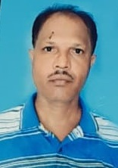

|  |  |
| --- | --- |
| **Designation:** | **Assistant Professor – III** |
| **Qualification:** | **MA, LLB, B.Ed, PhD** |
| **Whatsapp No.** | **97760 66880** |
| **NET/SLET Qualified** |  |
| **Ph.D(Awarded in the Year/ Name of the University/Title)** | **Yes,** |
| **Date of Entry in to OES** | **22/02/2001** |
| **ORCID ID** |  |
| **h-index** |  |
| **E-mail** |  |
| **No. of Years in N.C. Autonomous College/ Date of Joining** | **10 years (10/12/2013)** |

1. **Refresher Course/Orientation Programme/ Induction Programme/ FDP/ Short Course**

|  |  |  |  |  |  |
| --- | --- | --- | --- | --- | --- |
| **Sl.No.** | **Year** | **From-To** | **Type** | **Organizing Institute** | **Topic/Title** |
| **01** | **2021** | **3/11/2021 -16/11/2021** | **Online** | **Sambalpur University** | **Environmental studies** |
|  |  |  |  |  |  |
|  |  |  |  |  |  |
|  |  |  |  |  |  |
|  |  |  |  |  |  |

1. **Research Projects completed/under implementation:NIL**

|  |  |  |  |  |  |
| --- | --- | --- | --- | --- | --- |
| **Sl.No** | **Title** | **Cost in Lakhs** | **Duration/Status** | **Role** | **Agency** |
|  |  |  |  |  |  |

1. **Research Project Applied: NIL**

|  |  |  |  |  |  |
| --- | --- | --- | --- | --- | --- |
| **Sl.No** | **Title** | **Cost in Lakhs** | **Duration/Status** | **Role** | **Agency** |
|  |  |  |  |  |  |

1. **Professional Recognition/Award/Fellowship: NIL**

|  |  |  |  |
| --- | --- | --- | --- |
| **Sl.No** | **Name of Award** | **Awarding Agency** | **Year** |
|  |  |  |  |

1. **Research Publications in SCI/Scopus indexed Journals: NIL**

|  |  |  |  |  |  |  |
| --- | --- | --- | --- | --- | --- | --- |
| **Sl.No** | **Authors** | **Title** | **Journal Name** | **Volume** | **Page** | **Year** |
|  |  |  |  |  |  |  |

1. **Publications in Conference proceedings/Books/ Book Chapter: NIL**

|  |  |  |  |  |  |  |
| --- | --- | --- | --- | --- | --- | --- |
| **Sl No.** | **Title of the article** | **Proceeding/Book Name** | **Publisher** | **ISBN** | **Page** | **Year** |
|  |  |  |  |  |  |  |

1. **Conference/Seminar/Workshop paper presented/Resource person/participated:**

|  |  |  |  |  |
| --- | --- | --- | --- | --- |
| **Sl.No** | **Name of the Event** | **Organizing Institute** | **Duration** | **Title of the Paper presented/participated** |
| **01** |  |  |  |  |
| **02** |  |  |  |  |
| **03** |  |  |  |  |
| **04** |  |  |  |  |
| **05** |  |  |  |  |
| **06** |  |  |  |  |

1. **Reviewer for the Journals (SCI/Scopus Indexed): NIL**

|  |  |
| --- | --- |
| **Sl. No.** | **Name of the Journal** |
|  |  |

1. **NAME: SRI DOLAGOBINDA SETHI**

PHOTO

|  |  |
| --- | --- |
| **Designation:** | **Assistant Professor** |
| **Qualification:** | **MA Economics** |
| **Whatsapp No.** | **9938390059** |
| **NET/SLET Qualified** | **Yes, SLET** |
| **Ph.D(Awarded in the Year/ Name of the University/Title)** | **No** |
| **Date of Entry in to OES** | **03/03/2001** |
| **ORCID ID** |  |
| **h-index** |  |
| **E-mail** | [**dgsethi1971@gmail.com**](mailto:dgsethi1971@gmail.com) |
| **No. of Years in N.C. Autonomous College/ Date of Joining** | **2 years** |

1. **Refresher Course/Orientation Programme/ Induction Programme/ FDP/ Short Course**

|  |  |  |  |  |  |
| --- | --- | --- | --- | --- | --- |
| **Sl.No.** | **Year** | **From-To** | **Type** | **Organizing Institute** | **Topic/Title** |
| **01** | **2021** | **3/11/2021-16/11/2021** | **Refresher** | **Sambalpur University** | **Environmental Studies** |
| **02** | **2024** | **10/01/2024-23/01/2024** | **Refresher** | **Sambalpur University** | **Tribal Studies** |
|  |  |  |  |  |  |
|  |  |  |  |  |  |
|  |  |  |  |  |  |

1. **Research Projects completed/under implementation:NIL**

|  |  |  |  |  |  |
| --- | --- | --- | --- | --- | --- |
| **Sl.No** | **Title** | **Cost in Lakhs** | **Duration/Status** | **Role** | **Agency** |
|  |  |  |  |  |  |

1. **Research Project Applied: NIL**

|  |  |  |  |  |  |
| --- | --- | --- | --- | --- | --- |
| **Sl.No** | **Title** | **Cost in Lakhs** | **Duration/Status** | **Role** | **Agency** |
|  |  |  |  |  |  |

1. **Professional Recognition/Award/Fellowship: NIL**

|  |  |  |  |
| --- | --- | --- | --- |
| **Sl.No** | **Name of Award** | **Awarding Agency** | **Year** |
|  |  |  |  |

1. **Research Publications in SCI/Scopus indexed Journals: NIL**

|  |  |  |  |  |  |  |
| --- | --- | --- | --- | --- | --- | --- |
| **Sl.No** | **Authors** | **Title** | **Journal Name** | **Volume** | **Page** | **Year** |
|  |  |  |  |  |  |  |

1. **Publications in Conference proceedings/Books/ Book Chapter: NIL**

|  |  |  |  |  |  |  |
| --- | --- | --- | --- | --- | --- | --- |
| **Sl No.** | **Title of the article** | **Proceeding/Book Name** | **Publisher** | **ISBN** | **Page** | **Year** |
|  |  |  |  |  |  |  |

1. **Conference/Seminar/Workshop paper presented/Resource person/participated:**

|  |  |  |  |  |
| --- | --- | --- | --- | --- |
| **Sl.No** | **Name of the Event** | **Organizing Institute** | **Duration** | **Title of the Paper presented/participated** |
|  |  |  |  |  |
|  |  |  |  |  |
|  |  |  |  |  |
|  |  |  |  |  |
|  |  |  |  |  |
|  |  |  |  |  |

1. **Reviewer for the Journals (SCI/Scopus Indexed): NIL**

|  |  |
| --- | --- |
| **Sl. No.** | **Name of the Journal** |
|  |  |

1. **NAME: SRI ABINASH NAYAK**

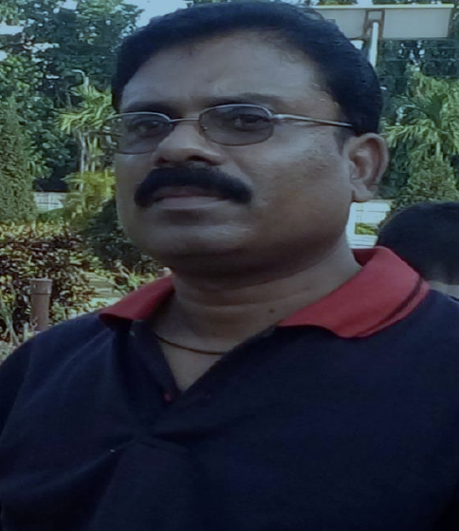

|  |  |
| --- | --- |
| **Designation:** | **Assistant professor- II** |
| **Qualification:** | M.A., M.Phil.(JNU,NEW DELHI),  M.A. (SOCIOLOGY, UNIVERSITY OF MADRAS, CHENNAI), MBA (SIKKIM MANIPAL UNIVERSITY, GANGTOK |
| **Whatsapp No.** | **+91-9437270503** |
| **NET/SLET Qualified** | **Yes (UGC NET)** |
| **Ph.D(Awarded in the Year/ Name of the University/Title)** | **No** |
| **Date of Entry in to OES** | **22/02/2001** |
| **ORCID ID** |  |
| **h-index** |  |
| **E-mail** | [**nayakabinash660@gmail.com**](mailto:nayakabinash660@gmail.com) |
| **No. of Years in N.C. Autonomous College/ Date of Joining** | **5 years (09/08/2018)** |

1. **Refresher Course/Orientation Programme/ Induction Programme/ FDP/ Short Course**

|  |  |  |  |  |  |
| --- | --- | --- | --- | --- | --- |
| **Sl.No.** | **Year** | **From-To** | **Type** | **Organizing Institute** | **Topic/Title** |
|  |  |  |  |  |  |
|  |  |  |  |  |  |
|  |  |  |  |  |  |
|  |  |  |  |  |  |
|  |  |  |  |  |  |

1. **Research Projects completed/under implementation:NIL**

|  |  |  |  |  |  |
| --- | --- | --- | --- | --- | --- |
| **Sl.No** | **Title** | **Cost in Lakhs** | **Duration/Status** | **Role** | **Agency** |
|  |  |  |  |  |  |

1. **Research Project Applied: NIL**

|  |  |  |  |  |  |
| --- | --- | --- | --- | --- | --- |
| **Sl.No** | **Title** | **Cost in Lakhs** | **Duration/Status** | **Role** | **Agency** |
|  |  |  |  |  |  |

1. **Professional Recognition/Award/Fellowship: NIL**

|  |  |  |  |
| --- | --- | --- | --- |
| **Sl.No** | **Name of Award** | **Awarding Agency** | **Year** |
|  |  |  |  |

1. **Research Publications in SCI/Scopus indexed Journals: NIL**

|  |  |  |  |  |  |  |
| --- | --- | --- | --- | --- | --- | --- |
| **Sl.No** | **Authors** | **Title** | **Journal Name** | **Volume** | **Page** | **Year** |
|  |  |  |  |  |  |  |

1. **Publications in Conference proceedings/Books/ Book Chapter: NIL**

|  |  |  |  |  |  |  |
| --- | --- | --- | --- | --- | --- | --- |
| **Sl No.** | **Title of the article** | **Proceeding/Book Name** | **Publisher** | **ISBN** | **Page** | **Year** |
| **1** | **Odisha Economy** | **Odisha Economy** | **V. K . Global Publications Pvt Ltd.** | **978-93-5612-653-4,** |  | **2023-24** |
| **2** | **Environmental Economics** | **Environmental Economics** | **V. K . Global Publications Pvt Limited** | **978-93-5512-022-8** |  | **2022-23** |
| **3** | **Money and Financial Markets** | **Money and Financial Markets** | **Vishal Publishing Co** | **978-93-91247-10-2** |  | **2022-23** |

1. **Conference/Seminar/Workshop paper presented/Resource person/participated:**

|  |  |  |  |  |
| --- | --- | --- | --- | --- |
| **Sl.No** | **Name of the Event** | **Organizing Institute** | **Duration** | **Title of the Paper presented/participated** |
|  |  |  |  |  |
|  |  |  |  |  |
|  |  |  |  |  |
|  |  |  |  |  |
|  |  |  |  |  |
|  |  |  |  |  |

1. **Reviewer for the Journals (SCI/Scopus Indexed): NIL**

|  |  |
| --- | --- |
| **Sl. No.** | **Name of the Journal** |
|  |  |

1. **NAME: SMT. HARAPRIYA SAHOO**

PHOTO

|  |  |
| --- | --- |
| **Designation:** | **Lecture in Economics (Adhoc)** |
| **Qualification:** | **M.A., M.Phil** |
| **Whatsapp No.** | **9937350031** |
| **NET/SLET Qualified** | **No** |
| **Ph.D(Awarded in the Year/ Name of the University/Title)** | **No** |
| **Date of Entry in to OES** | **15/09/2014** |
| **ORCID ID** |  |
| **h-index** |  |
| **E-mail** | [**Harapriya42@gmail.com**](mailto:Harapriya42@gmail.com) |
| **No. of Years in N.C. Autonomous College/ Date of Joining** | **9 years (15/09/2014)** |

1. **Refresher Course/Orientation Programme/ Induction Programme/ FDP/ Short Course**

|  |  |  |  |  |  |
| --- | --- | --- | --- | --- | --- |
| **Sl.No.** | **Year** | **From-To** | **Type** | **Organizing Institute** | **Topic/Title** |
|  |  |  |  |  |  |
|  |  |  |  |  |  |
|  |  |  |  |  |  |
|  |  |  |  |  |  |
|  |  |  |  |  |  |

1. **Research Projects completed/under implementation:NIL**

|  |  |  |  |  |  |
| --- | --- | --- | --- | --- | --- |
| **Sl.No** | **Title** | **Cost in Lakhs** | **Duration/Status** | **Role** | **Agency** |
|  |  |  |  |  |  |

1. **Research Project Applied: NIL**

|  |  |  |  |  |  |
| --- | --- | --- | --- | --- | --- |
| **Sl.No** | **Title** | **Cost in Lakhs** | **Duration/Status** | **Role** | **Agency** |
|  |  |  |  |  |  |

1. **Professional Recognition/Award/Fellowship: NIL**

|  |  |  |  |
| --- | --- | --- | --- |
| **Sl.No** | **Name of Award** | **Awarding Agency** | **Year** |
|  |  |  |  |

1. **Research Publications in SCI/Scopus indexed Journals: NIL**

|  |  |  |  |  |  |  |
| --- | --- | --- | --- | --- | --- | --- |
| **Sl.No** | **Authors** | **Title** | **Journal Name** | **Volume** | **Page** | **Year** |
|  |  |  |  |  |  |  |

1. **Publications in Conference proceedings/Books/ Book Chapter: NIL**

|  |  |  |  |  |  |  |
| --- | --- | --- | --- | --- | --- | --- |
| **Sl No.** | **Title of the article** | **Proceeding/Book Name** | **Publisher** | **ISBN** | **Page** | **Year** |
|  |  |  |  |  |  |  |

1. **Conference/Seminar/Workshop paper presented/Resource person/participated:**

|  |  |  |  |  |
| --- | --- | --- | --- | --- |
| **Sl.No** | **Name of the Event** | **Organizing Institute** | **Duration** | **Title of the Paper presented/participated** |
|  |  |  |  |  |
|  |  |  |  |  |
|  |  |  |  |  |
|  |  |  |  |  |
|  |  |  |  |  |
|  |  |  |  |  |

1. **Reviewer for the Journals (SCI/Scopus Indexed): NIL**

|  |  |
| --- | --- |
| **Sl. No.** | **Name of the Journal** |
|  |  |

1. **NAME: SRI. NITYASUNDAR MANIK**

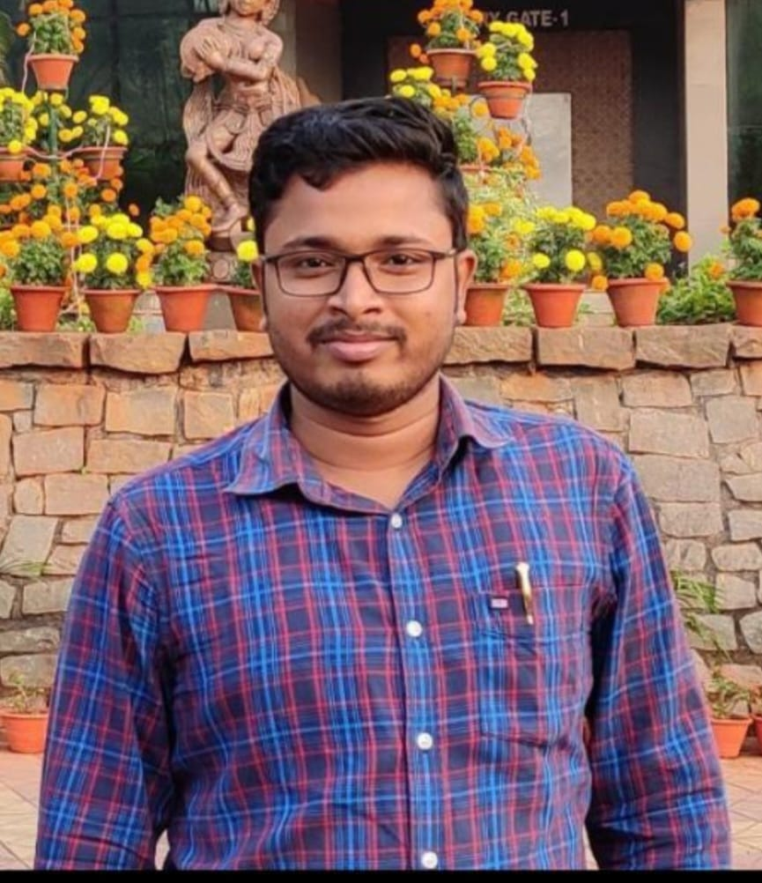

|  |  |
| --- | --- |
| **Designation:** | **Assistant Professor - I** |
| **Qualification:** | **M.A., M.Phil** |
| **Whatsapp No.** | **9703490531** |
| **NET/SLET Qualified** | **Yes, UGC NET & JRF** |
| **Ph.D(Awarded in the Year/ Name of the University/Title)** | **Submitted** |
| **Date of Entry in to OES** | **29/08/2023** |
| **ORCID ID** | **0000-0002-3341-079X** |
| **h-index** | **02** |
| **E-mail** | [**Nitya.baban@gmail.com**](mailto:Nitya.baban@gmail.com) |
| **No. of Years in N.C. Autonomous College/ Date of Joining** | **8 Months (29/08/2023)** |

1. **Refresher Course/Orientation Programme/ Induction Programme/ FDP/ Short Course**

|  |  |  |  |  |  |
| --- | --- | --- | --- | --- | --- |
| **Sl.No.** | **Year** | **From-To** | **Type** | **Organizing Institute** | **Topic/Title** |
|  |  |  |  |  |  |
|  |  |  |  |  |  |
|  |  |  |  |  |  |
|  |  |  |  |  |  |
|  |  |  |  |  |  |

1. **Research Projects completed/under implementation:NIL**

|  |  |  |  |  |  |
| --- | --- | --- | --- | --- | --- |
| **Sl.No** | **Title** | **Cost in Lakhs** | **Duration/Status** | **Role** | **Agency** |
|  |  |  |  |  |  |

1. **Research Project Applied: NIL**

|  |  |  |  |  |  |
| --- | --- | --- | --- | --- | --- |
| **Sl.No** | **Title** | **Cost in Lakhs** | **Duration/Status** | **Role** | **Agency** |
|  |  |  |  |  |  |

1. **Professional Recognition/Award/Fellowship: NIL**

|  |  |  |  |
| --- | --- | --- | --- |
| **Sl.No** | **Name of Award** | **Awarding Agency** | **Year** |
|  |  |  |  |

1. **Research Publications in SCI/Scopus indexed Journals: NIL**

|  |  |  |  |  |  |  |
| --- | --- | --- | --- | --- | --- | --- |
| **Sl.No** | **Authors** | **Title** | **Journal Name** | **Volume** | **Page** | **Year** |
|  |  |  |  |  |  |  |

1. **Publications in Conference proceedings/Books/ Book Chapter: NIL**

|  |  |  |  |  |  |  |
| --- | --- | --- | --- | --- | --- | --- |
| **Sl No.** | **Title of the article** | **Proceeding/Book Name** | **Publisher** | **ISBN** | **Page** | **Year** |
|  |  |  |  |  |  |  |

1. **Conference/Seminar/Workshop paper presented/Resource person/participated:**

|  |  |  |  |  |
| --- | --- | --- | --- | --- |
| **Sl.No** | **Name of the Event** | **Organizing Institute** | **Duration** | **Title of the Paper presented/participated** |
| **1** | Two-Day International Conference on New Frontiers in Economic And Financial Research | Gangadhar Meher University | 30-31 January, 2024 | Public Debt and Economic Growth Nexus in India: A Symmetrical and Asymmetrical Approach |
| **2** | Departmental Seminar of Economics as a Resource Person | Pattamundai college, Kendrapara | 09th November 2023 | Empowering Women in the Labour Market: Insight from the 2023 Nobel Prize in Economics Sciences |
|  |  |  |  |  |
|  |  |  |  |  |
|  |  |  |  |  |
|  |  |  |  |  |

1. **Reviewer for the Journals (SCI/Scopus Indexed): NIL**

|  |  |
| --- | --- |
| **Sl. No.** | **Name of the Journal** |
|  |  |

1. **NAME: DR. PRADIPTA KUMAR SAHOO**

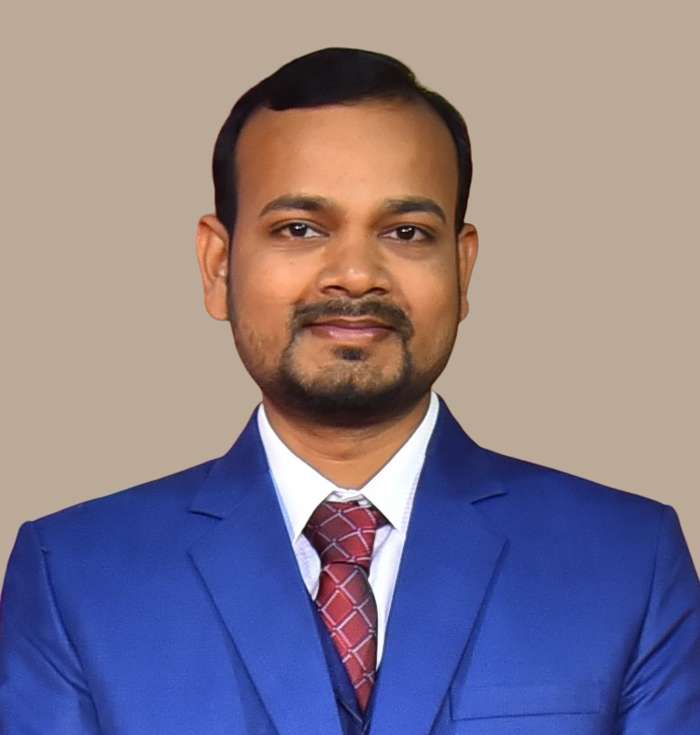

|  |  |
| --- | --- |
| **Designation:** | Assistant Professor - I |
| **Qualification:** | M.A., M.Phil, PhD. |
| **Whatsapp No.** | 7382064392 |
| **NET/SLET Qualified** | Yes |
| **Ph.D(Awarded in the Year/ Name of the University/Title)** | 2022, IIT Hyderabad & Swinburne University of Technology, Australia  Title: Competitiveness of the Indian Manufacturing Sectors: An Inter-Industry Perspective |
| **Date of Entry in to OES** | 05/09/2023 |
| **ORCID ID** | 0000-0001-9670-2004 |
| **h-index** | 10 |
| **E-mail** | [pradiptaiith@gmail.com](mailto:pradiptaiith@gmail.com) |
| **No. of Years in N.C. Autonomous College/ Date of Joining** | 8 months (05/09/2023) |

1. **Refresher Course/Orientation Programme/Induction Programme/ FDP/Short Course: NIL**

|  |  |  |  |  |  |
| --- | --- | --- | --- | --- | --- |
| **Sl.No.** | **Year** | **From-To** | **Type** | **Organizing Institute** | **Topic/Title** |
|  |  |  |  |  |  |
|  |  |  |  |  |  |
|  |  |  |  |  |  |
|  |  |  |  |  |  |
|  |  |  |  |  |  |

1. **Research Projects completed/under implementation:NIL**

|  |  |  |  |  |  |
| --- | --- | --- | --- | --- | --- |
| **Sl.No** | **Title** | **Cost in Lakhs** | **Duration/Status** | **Role** | **Agency** |
|  |  |  |  |  |  |

1. **Research Project Applied: NIL**

|  |  |  |  |  |  |
| --- | --- | --- | --- | --- | --- |
| **Sl.No** | **Title** | **Cost in Lakhs** | **Duration/Status** | **Role** | **Agency** |
|  |  |  |  |  |  |

1. **Professional Recognition/Award/Fellowship: NIL**

|  |  |  |  |
| --- | --- | --- | --- |
| **Sl.No** | **Name of Award** | **Awarding Agency** | **Year** |
|  |  |  |  |

1. **Research Publications in SCI/Scopus indexed Journals**

|  |  |  |  |  |  |  |
| --- | --- | --- | --- | --- | --- | --- |
| **Sl.No** | **Authors** | **Title** | **Journal Name** | **Volume** | **Page** | **Year** |
| **1** | **Sahoo, P. K.,** Pahi, D., Guru, B. K., & Mohanty, N. | Causal Nexus Between COVID-19 Risk and Global Oil Price Shocks: Evidence from a Time and Frequency Causality Approach. | *Energy RESEARCH LETTERS* | 4 | 15 | 2024 |
| **2** | Jallow, S., Sahoo, P. K., & Mahapatra, B. | Promoting Financial Inclusivity, a Route to Economic Growth: An Empirical Analysis from Sub-Saharan African Countries | *Bulletin of Monetary Economics and Banking*, | *27* | 59-74 | 2024 |

1. **Publications in Conference proceedings/Books/ Book Chapter: NIL**

|  |  |  |  |  |  |  |
| --- | --- | --- | --- | --- | --- | --- |
| **Sl No.** | **Title of the article** | **Proceeding/Book Name** | **Publisher** | **ISBN** | **Page** | **Year** |
|  |  |  |  |  |  |  |

1. **Conference/Seminar/Workshop paper presented/Resource person/participated:**

|  |  |  |  |  |
| --- | --- | --- | --- | --- |
| **Sl.No** | **Name of the Event** | **Organizing Institute** | **Duration** | **Title of the Paper presented/participated** |
| **1** | Two-Day International Conference on New Frontiers in Economic And Financial Research | Gangadhar Meher University | 30-31 January, 2024 | Agricultural Growth and Economic Convergence: A Special Case for the Development of Indian States |
| **2** | The 17th Bulletin of Monetary Economics and Banking (BMEB) International Conference and Call for Papers | Bank Indonesia Institute | 16th September, 2023. | Promoting Financial Inclusivity, a Route to Economic Growth: An Empirical Analysis from Sub-Saharan African Countries |

1. **Reviewer for the Journals (SCI/Scopus Indexed)**

|  |  |
| --- | --- |
| **Sl. No.** | **Name of the Journal** |
|  | * The Singapore Economic Review, **World Scientific Publisher** * North American Journal of Economics and Finance, **Elsevier Publisher.** * Financial Innovation, **Springer Publisher**. * Economic Analysis and Policy, **Elsevier Publisher.** * Studies in Economics and Finance, **Emerald Publisher**. * Emerging Markets Finance and Trade, **Routledge, Taylor & Francis Publisher.** * Applied Economics, **Routledge, Taylor & Francis Publisher.** * Journal of Public Affairs, **Wiley-Blackwell Publisher**. * Journal of Economic Studies, **Emerald Publisher**. * International Journal of Managerial Finance, **Emerald Publisher**. * International Journal of Energy Sector Management, **Emerald Publisher.** |

**INFRASTRUCTURAL FACILITIES OF DEPARTMENT**

|  |  |  |  |
| --- | --- | --- | --- |
| **Sl.No** | **No of Rooms** | **No. of Labs** | **No. of Staff Room** |
|  |  |  |  |

**DETAILS ABOUT LIBRARY/ BOOK BANK OF DEPARTMENT**

|  |  |  |  |  |  |
| --- | --- | --- | --- | --- | --- |
| Name of the Book | Authors | Publishers | Year of Purchase | Cost of the Book | Remarks (if any) |
|  |  |  |  |  |  |

**STRENGTH, WEKNESS, OPPORTUNITIES AND CHALLENGES (SWOC) OF THE DEPARTMENT:**

STRENGTH: Numerical strength of girl students

WEAKNESS: Rural-based college with Odia Medium Students

OPPORTUNITY: Optimum utilization of market-oriented specialization economics subjects.

CHALLENGE: Limited exposure to Database and software packages for econometrics work.

**FUTURE PLAN OF DEPARTMENT:**

1. Proposal for Smart Class Room for Students
2. Proposal for opening an Econometrics lab for both UG and PG students.